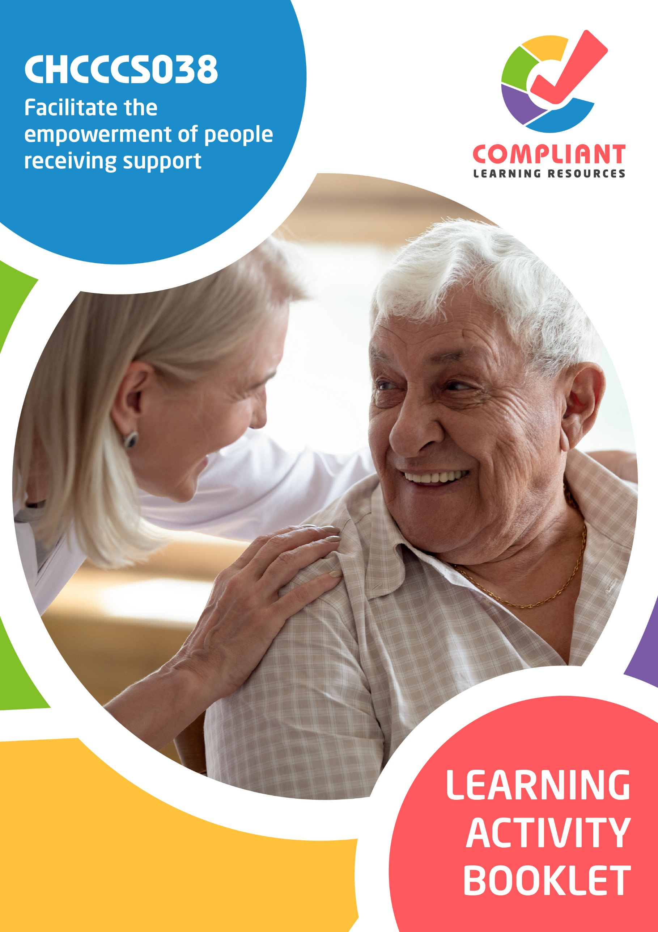

**Copyright**

This document was developed by Compliant Learning Resources.

© 2022 Compliant Learning Resources.

All rights reserved.

No part of this publication may be reproduced, stored in a retrieval system, or transmitted in any form or by any means, electronic, mechanical, photocopying, recording, or otherwise without the prior written permission of Compliant Learning Resources.

**Version Control & Document History**

|  |  |  |
| --- | --- | --- |
| **Date** | **Summary of Modifications** | **Version** |
| 23 December 2022 | Version 1.0 released for publishing | 1.0 |
| 3 November 2023 | Version 1.1 Contextualisation for IIET | 1.1 |

# Table of Contents

Overview 4

Learner Instructions 5

Learner Information 5

Trainer Information 5

Resources Required 6

Work Health and Safety 6

Reasonable Adjustment 7

Formative Activities 8

I. Demonstrate Commitment to Empower People Receiving Support 8

Activity 1.1 8

Activity 1.2 9

Activity 1.3 10

II. Foster Human Rights 11

Activity 2.1 11

Activity 2.2 12

Activity 2.3 14

III. Facilitate Choice and Self-Determination 16

Activity 3.1 16

Activity 3.2 17

# Overview

**CHCCCS038 - Facilitate the empowerment of people receiving support (Release 1)**

This unit describes the performance outcomes, skills and knowledge required to facilitate the empowerment of people receiving support, and to deliver rights-based services using a person-centred approach. It should be carried out in conjunction with individualised plans.

This unit applies to workers in varied care and support contexts.

The skills in this unit must be applied in accordance with Commonwealth and State/Territory legislation, Australian standards and industry codes of practice.

No occupational licensing, certification or specific legislative requirements apply to this unit at the time of publication.

**A complete copy of the above unit of competency can be downloaded from the TGA website:**

<https://training.gov.au/Training/Details/CHCCCS038>

# Learner Instructions

This Learning Activity Booklet contains formative activities that learners will complete in the classroom or a similar environment.

These formative activities include knowledge questions to test your underpinning generic knowledge and practical activities to test your skills relevant to the unit/s of competency.

These formative assessments are used by your trainer to complement both the learning and training processes, and to evaluate how you are progressing throughout these processes.

You may reference your Learner Guide and other learning materials to complete the activities included in this workbook.

**IMPORTANT:**

**The completion of the formative assessments and learning activities included in this workbook DOES NOT lead to a Qualification or a Statement of Attainment (SOA).**

## Learner Information

|  |  |
| --- | --- |
| Learner name |  |
| Phone |  |
| Email |  |

## Trainer Information

|  |  |
| --- | --- |
| Trainer name |  |
| RTO name |  |
| RTO phone |  |
| RTO email |  |

# Resources Required

Resources needed to complete activities included in this workbook include:

* Computer with Internet, email access, and a working web browser
* Installed software: MS Word, Adobe Acrobat Reader
* Learner guide
* Volunteers to participate in a role play activity

# Work Health and Safety

Both the trainers and learners have duty of care in ensuring that the learning environment is free from hazards that may pose risks to their health and safety.

According to WHS legislation, trainers and learners must take reasonable care while undertaking the activities included in this workbook in the learning environment.

# Reasonable Adjustment

‘Reasonable adjustment’ in VET is the term applied to modifying the learning environment or making changes to the training delivered to assist a learner with a disability. A reasonable adjustment can be as simple as changing classrooms to be closer to amenities or installing a particular type of software on a computer for a person with vision impairment.

**Why make a reasonable adjustment?**

We make reasonable adjustments in VET to make sure that learners with disabilities have:

* The same learning opportunities as learners without disabilities, and
* The same opportunity to perform and complete assessments as those without disabilities.

**Reasonable adjustment applied to participation in teaching, learning, and assessment activities can include:**

* Customising resources and assessment activities within the training package or accredited course
* Modifying the presentation medium
* Learner support
* Use of assistive/adaptive technologies
* Making information accessible both before enrolment and during the course
* Monitoring the adjustments to ensure learner needs continue to be met

**Assistive/Adaptive Technologies**

Assistive/adaptive technology means ‘software or hardware that has been specifically designed to assist people with disabilities in carrying out daily activities’ (World Wide Web Consortium - W3C). It includes screen readers, magnifiers, voice recognition software, alternative keyboards, devices for grasping, visual alert systems, and digital note-takers.

*(Adapted Reasonable Adjustment in teaching, learning and assessment for learners with a disability - November 2010 - Prepared by - Queensland VET Development Centre)*

**IMPORTANT:**

**Reasonable adjustment made for collecting learner assessment evidence must not impact the standard expected by the workplace, as expressed by the relevant unit/s of competency. For example, if the assessment were gathering evidence of the learner’s competency in writing, allowing the learner to complete the assessment verbally would not be a valid assessment method. The method of assessment used by any reasonable adjustment must still meet the competency requirements.**

# Formative Activities

## I. Demonstrate Commitment to Empower People Receiving Support

### Activity 1.1

|  |  |
| --- | --- |
| **Matching Type**  Listed below are frameworks for work that involves people receiving support.   1. Legal Frameworks 2. Political Frameworks 3. Structural Frameworks 4. Systemic Frameworks 5. Social Frameworks   Match each to their description below, by writing the letter that corresponds to your answer in the space provided. | |
|  | |
| Description | |
|  | 1. These are the considerations and standards of practice. |
|  | 1. These are a collection of laws, conditions, and arrangements that form the overall legal context. |
|  | 1. These are sets of ideas and rules relevant to management and governance. |
|  | 1. These influence the policies and procedures of an organisation. |
|  | 1. These are the underlying structures that detail the connection of different people. |

### Activity 1.2

|  |  |
| --- | --- |
| **True or False**  Review the statements below about the ethical and legal considerations for working with people receiving support. Indicate whether each statement is True or False.  Tick the box that corresponds to your answer. | |
|  | |
| TRUE  FALSE | 1. A code of conduct is the policy that lays out an organisation‘s principles and standards. It also outlines various expectations that all care workers must adhere to. |
| TRUE  FALSE | 1. Not acting to protect a person from harm does not constitute a breach of duty of care. |
| TRUE  FALSE | 1. Care workers do not need to determine whether a person is suffering from any harm and is in need of immediate help. |
| TRUE  FALSE | 1. Work-role boundaries are used to define your responsibilities when supporting a client. They act as limitations on what the client can ask from you. |
| TRUE  FALSE | 1. Work health and safety practices ensure the safety of you, the person, and those involved in their care. This means protection against illnesses and harm from elements in the immediate environment. |
| TRUE  FALSE | 1. Adherence to standards is voluntary, even when they are referred to in legislation. |

### Activity 1.3

|  |
| --- |
| **SCENARIO**  You are the aged care worker for Kate Dawson, an elderly patient with dementia. Kate has difficulty understanding other people during conversations. In your last meeting with Kate, she shared that she has a hard time understanding you as you talk really fast. She often feels embarrassed and does not feel comfortable sharing her needs with you. |

|  |
| --- |
| Briefly explain how you can adjust your approach based on the feedback given by Kate. |
|  |
|  |

|  |
| --- |
| List down two ways you can verbally communicate with Kate based on her needs. |
|  |
|  |
|  |

## II. Foster Human Rights

### Activity 2.1

|  |
| --- |
| **Fill in the blanks**  The following are statements on the principles of a human rights-based approach. Review each and complete the statement by filling in the missing words/phrases. |
|  |
| 1. Everyone has the right to       in decisions that affect their human rights. Participation must be active, accessible, and meaningful. It must give attention to issues of      , including access to information in a form and a language that can be understood. |
| 1. Accountability requires effective       with human rights standards and achievement of human rights goals, as well as effective remedies for breaches of human rights. For accountability to be effective, there must be appropriate laws, policies, institutions, administrative procedures, and mechanisms of redress in order to secure      . |
| 1. A human rights-based approach means that all forms of discrimination in the realisation of rights must be      . It also means that priority should be given to people in the most       who face the biggest barriers to realising their rights. |
| 1. Everyone is entitled to claim and exercise their rights and freedoms. Individuals and communities need to be able to       and to fully participate in the development of       which affect their lives. |
| 1. A human rights-based approach requires that the law recognises human rights and freedoms as       entitlements, and the law itself is      . |

### Activity 2.2

|  |  |  |  |  |  |  |  |  |  |
| --- | --- | --- | --- | --- | --- | --- | --- | --- | --- |
| **Matching Type**  Identify the genetic disorders being described in each statement below.   |  | | --- | | **Genetic Disorders** | | Attention Deficit Hyperactivity Disorder | | Down Syndrome | | Cri du Chat Syndrome | | Cystic Fibrosis | | Fragile X Syndrome | | Huntington’s Disease | | Sickle Cell Disease | | |
|  | |
| Description | |
|  | 1. This is a chromosomal condition affecting chromosome 21. Around 1 in 800 to 1 in 1,000 infants are born with this disorder. |
|  | 1. It is a common but dangerous genetic disease. This disorder causes the body to produce viscous mucus that can clog a person’s lungs. |
|  | 1. It is an inherited red blood cell disorder caused by a genetic mutation. People with this disorder have their red blood cells destroyed faster than they can be replaced, causing anaemia. |

|  |  |
| --- | --- |
| Description | |
|  | 1. This disorder is a common neurological disorder that affects, mood, behaviour, learning, and social interaction. It primarily affects a person’s self-regulation and attention span. |
|  | 1. This is an inherited neurological illness. Patients with this disorder experience involuntary movements, severe emotional disturbance, and rapid cognitive decline. |
|  | 1. This is a rare genetic condition. It is characterised by a high-pitched cat-like cry that diminishes with age and intellectual disability. |
|  | 1. This is an inherited intellectual disability cause by a mutation in the FMR1 gene. This disorder is characterised by a particular facial appearance, which includes having a large head. |

### Activity 2.3

|  |
| --- |
| **SCENARIO**  You have been assigned to be the disability support worker of Sia Lakshmi, who is a very religious woman of the Hindu faith. For you to provide appropriate support, you must consult with Sia to identify her cultural needs.  Prior to the consultation, you review Sia’s individualised plan. It is noted that Sia prefers to converse in Tamil. As such, you request for a professional interpreter to be onsite during your consultation with Sia. |

|  |
| --- |
| **Role Play Activity**  Role play the scenario with two volunteer to consult with the client to confirm their cultural needs while demonstrating the practical skills listed in the checklist below.  Perform this activity while being observed by your trainer. If your trainer is not available to directly observe you, you may video record the role play activity and submit the recording to your trainer.  **Your role**  For this activity, you will take the role of the disability support worker.  **The volunteers’ role**  For this activity, the volunteers will take the role of:   * The client * The professional interpreter |

|  |  |  |
| --- | --- | --- |
| **Role Play Checklist** (For trainer’s use only) | | |
| **During the role play activity:** | **YES** | **NO** |
| 1. The learner demonstrates positive verbal communication by: |  |  |
| * 1. Speaking directly to the client rather than the professional interpreter. |  |  |
| * 1. Avoiding the use of discriminatory phrasing. |  |  |
| * 1. Letting the client know if they have difficulty understanding them. |  |  |
| 1. The learner asks the client questions about their: |  |  |
| * 1. Cultural needs |  |  |
| * 1. Religious observance needs |  |  |
| * 1. Dietary needs |  |  |
| 1. The learner provides information on what support the client can expect from the learner. |  |  |
| 1. The learner provides information on what support the client can expect from the organisation. |  |  |
| Trainer’s overall feedback on the learner’s performance during the role play activity: | | |

## III. Facilitate Choice and Self-Determination

### Activity 3.1

|  |  |
| --- | --- |
| **Matching Type**  Listed below are the assistive technology for daily living activities.   1. Bedpans 2. Anti-slip mats 3. Prosthetic devices 4. Utensil holders 5. Assistive cups and mugs 6. Offloading footwear 7. Fall detectors   Match each to their description below, by writing the letter that corresponds to your answer in the space provided. | |
|  | |
| Description | |
|  | 1. These are sensors that alert a carer if someone has taken a fall. |
|  | 1. These are receptables used for both urinary and faecal discharge. |
|  | 1. These are for people who find holding utensils challenging. |
|  | 1. These are rubber mats placed inside and outside the shower or bathtub. |
|  | 1. These are devices that imitate the human body’s movement depending on the device’s complexity. |
|  | 1. This is a type of footwear designed to redistribute pressure. |
|  | 1. These are designed to assist a person to drink. |

### Activity 3.2

|  |
| --- |
| List down and describe five impacts of the structural and systemic obstacles on a person’s empowerment. |

|  |  |
| --- | --- |
| **Impacts of the structural and systemic obstacles on a person’s empowerment** | **Description** |
|  |  |
|  |  |
|  |  |
|  |  |
|  |  |

End of Document